Part 2 Report

I added these lines to get the predict_test.py and predict.py to work.

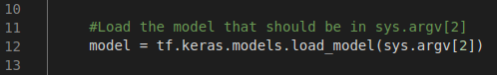

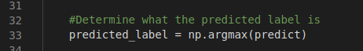

So for this image of an “A” that I drew from using grabimage.py my model identified it as an F:
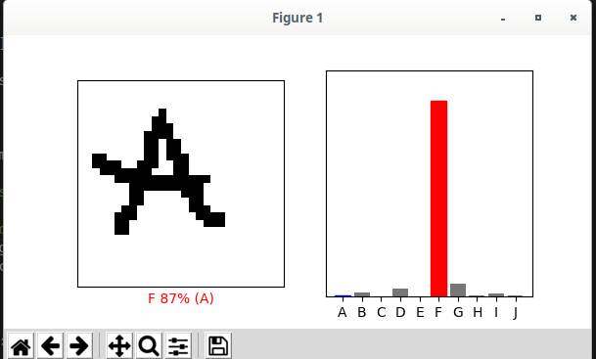

After adding a learning rate I get this, still doesn’t recognize it as an “A” but compared to the previous model without a learning rate it does much better in identifying that it’s an “A”:

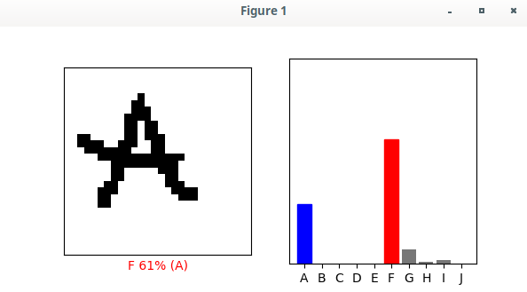

This means that the learning rate that I implemented is working to a degree and identifying it more as an “A” then when it was previously run.

So what I did to improve the result is implement a learning rate in the notMNISTStarter.py as shown below:
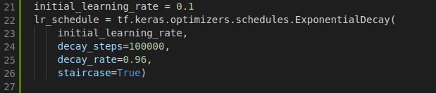
I also changed this line when I compiled the model. Changed optimizer from adam to SGD and added the learning rate into this optimizer:

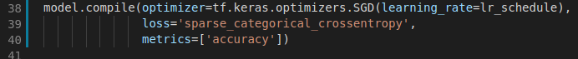

This also didn't change my models accuracy when I implemented this learning rate.

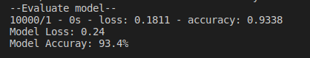
before accuracy:

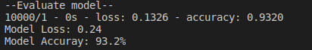
after accuracy:

